3- Selenium

CSS Selectors as Locators:

For complex projects, it’s hard to locate an element using attribute locators such as id, className, tagName etc., where we depend on single name only.

These attribute locators are nothing but the attributes of html tags where we are able to find directly in html code.

So, in such complex projects, we use locators as CSS Selector for ease

CSS Selector can be combinations such as:
Tag id tag#id
Tag class tag.classname
Tag attribute tag[attribute=”value”]
Tag class attributetag.classname[attribute=”value”]

1) Tag id tag#id

driver.findElement(By.cssSelector("input#autocomplete")).sendKeys("some name");
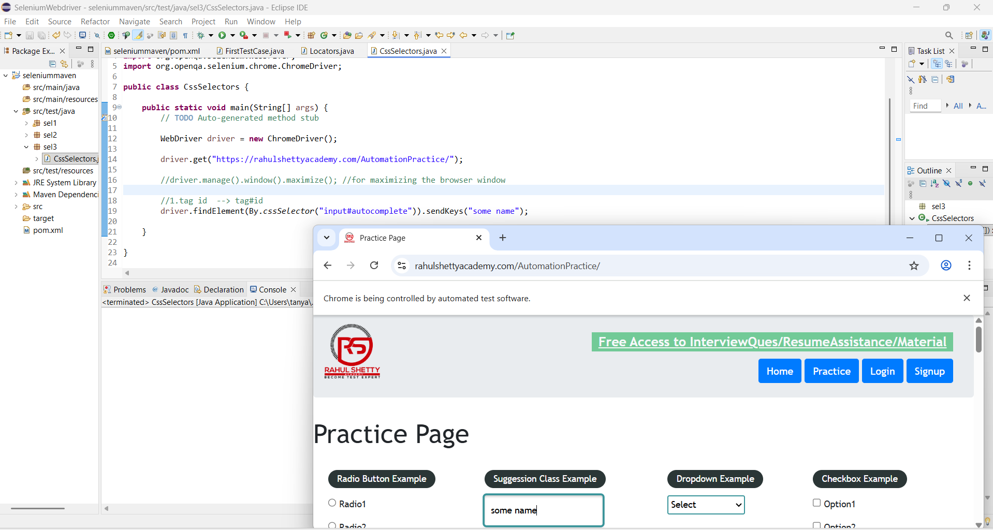
driver.findElement(By.cssSelector("#autocomplete")).sendKeys("some name");
/*tag name in any case is optional. Without specifying the tagname also, we will ge the same result in css selectors*/

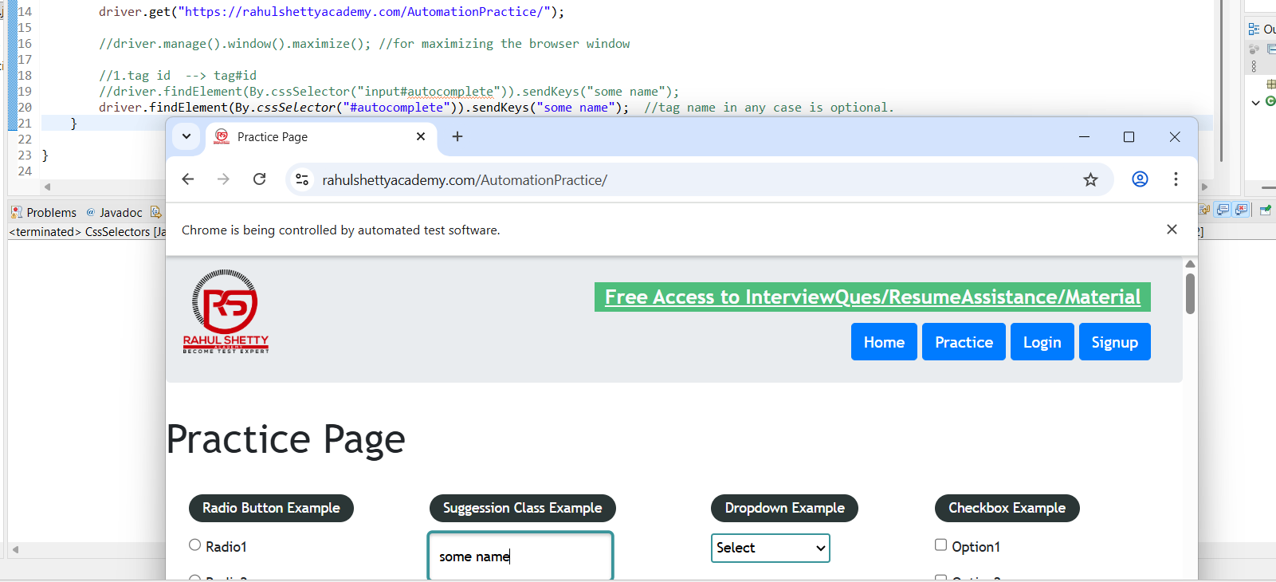

2)Tag class tag.classname
driver.findElement(By.cssSelector(".gf-li")).click();
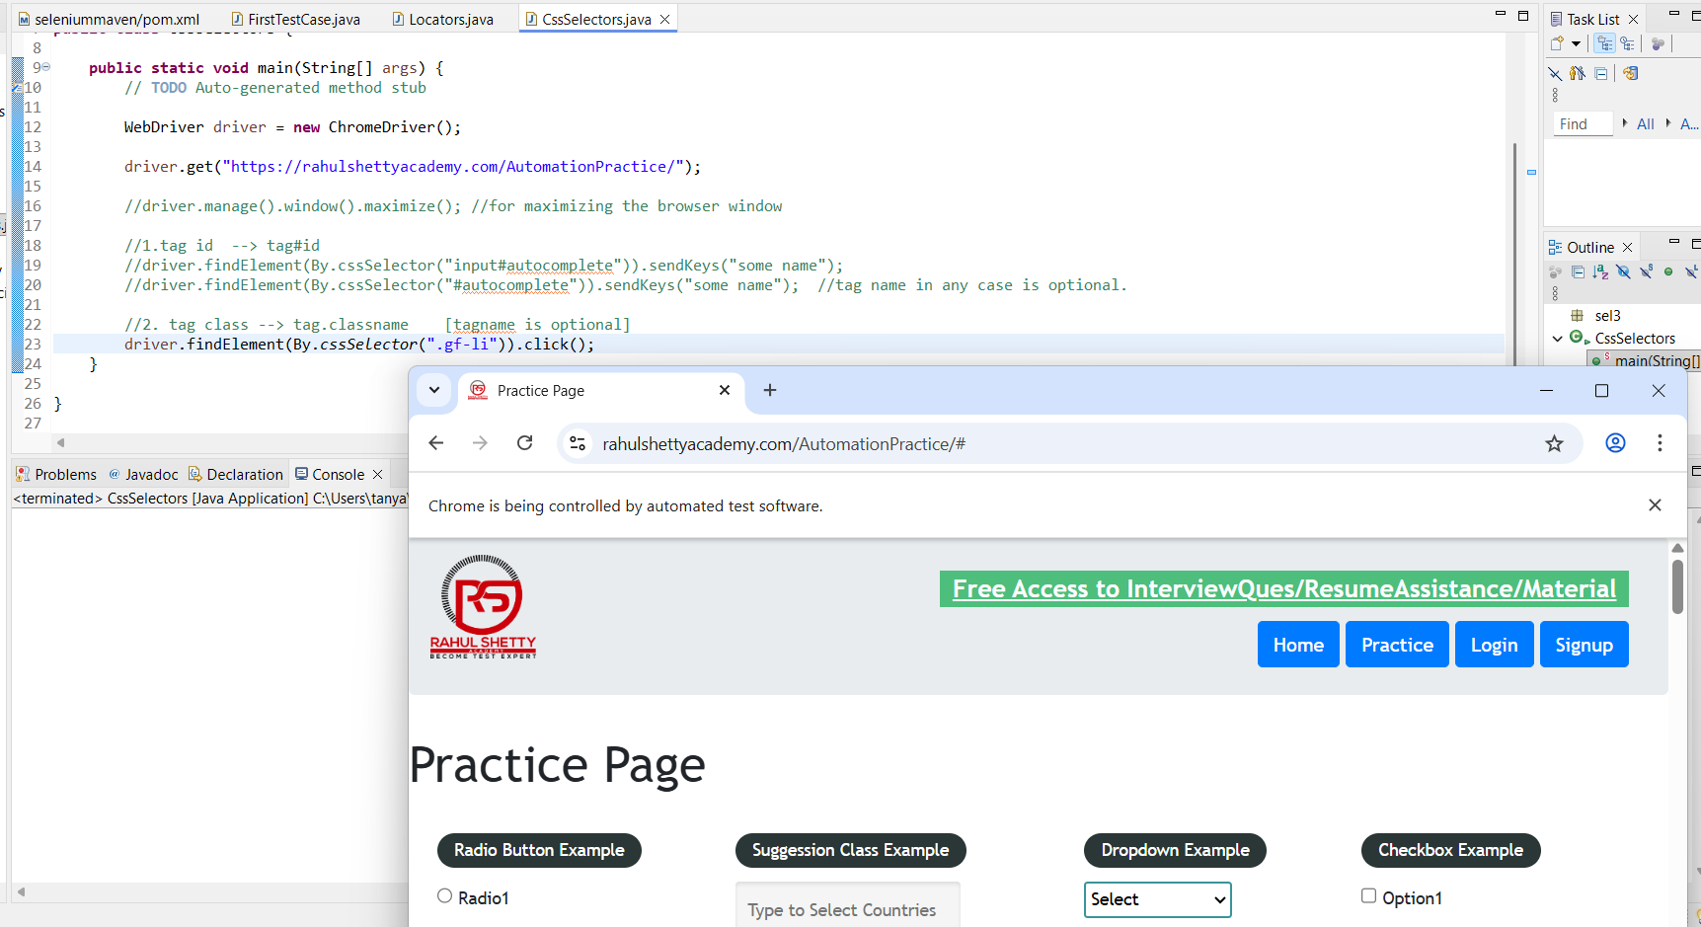

3) Tag attribute tag[attribute=”value”]
driver.findElement(By.cssSelector("[placeholder='Hide/Show Example']")).sendKeys("some content");
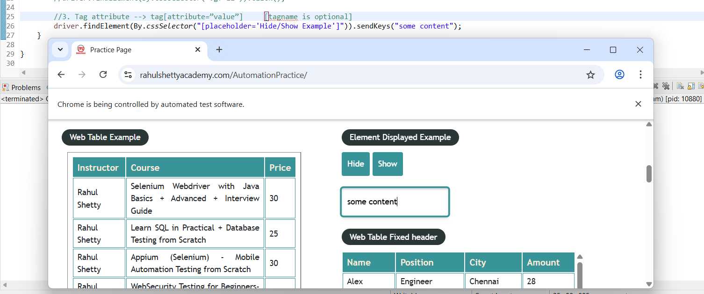

4) Tag class attributetag.classname[attribute=”value”]

This is used specifically when there’s same classname, leading to difficulty in locating the specific element. For example, in below Hide & Show buttons, class is same, let’s say we need to click Show button specifically, then we use Tag class attribute as cssSelector

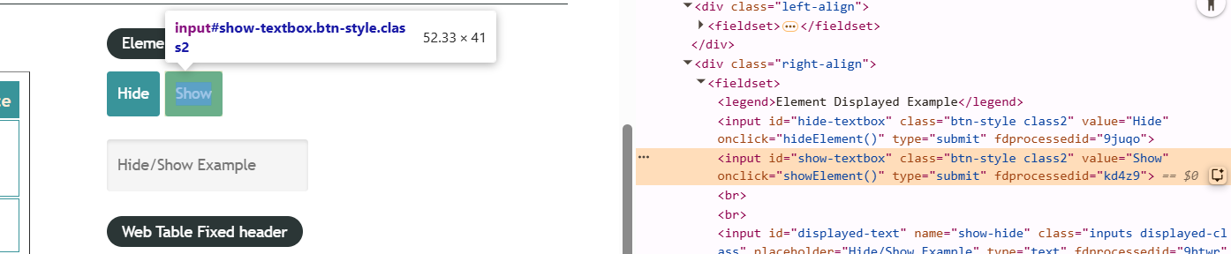

Example 2:
Now let’s write script to type text as Tanya Coder in input text box whose classname is inputs and has attribute called name with value as enter-name

driver.findElement(By.cssSelector(".inputs[name='enter-name']")).sendKeys("Tanya Coder");
